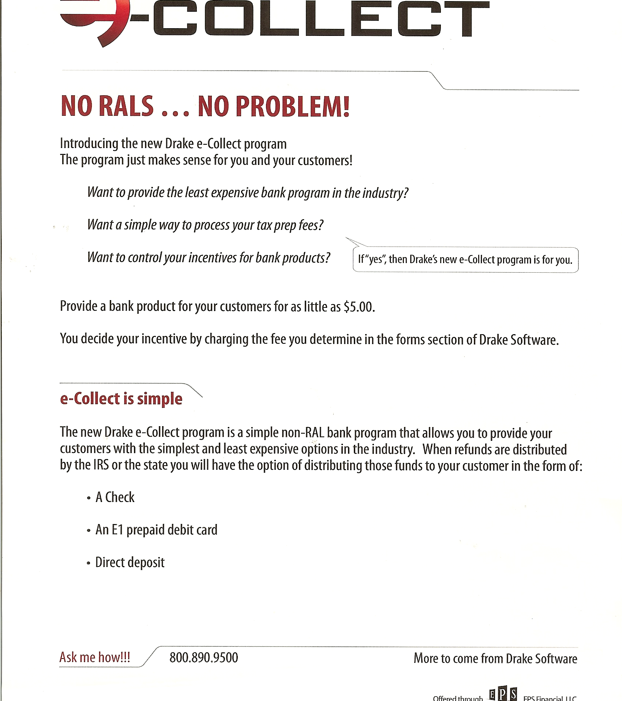
303.525.1561
Providing a bank product for you for as little as $5.
e-COLLECT

